Chapter 11
Environmental Technology and Legal Implications

Introduction
This chapter illustrates the role of computers in a modern environment under the headings of; Ergonomics, The Data Protection Act and Computers role in society. It defines the term ‘Ergonomics’ and states the general rules for good ergonomic practices at a computer. It also looks into the roll of the Data Protection Act in Ireland and sees what implications it has for the individual, the holder of data and the legislative body. The chapter then looks into the role of computers in society and investigates how computers have changed our environment, personal and working relationships and how it impacts economies.

Ergonomics
This is the study of fitting a person to a machine. This is not just for computers. Ergonomics is used in the development of cars, industrial machinery and sports equipment to ensure that the person using the device is comfortable and is using their strength in the best possible way.
Ergonomics rules for computers are as follows.
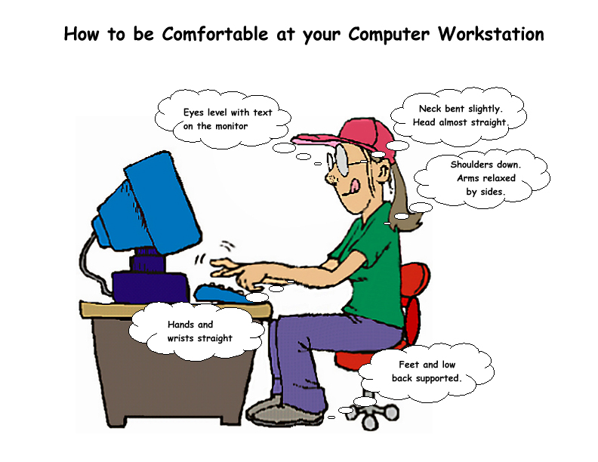

- Your eyes should be level with the top of the monitor. You should not have to look up to see the top of the screen
- Tour hands and wrists should be straight and not resting on anything as this can aggravate Carpel Tunnel Syndrome
- Your feet and lower back should be supported
- Your knees should not be resting on the edge of the chair and should be bent at 90° or greater
- You should be looking straight at the monitor and not off to one side
- You should only use the computer continuously for 30 minutes at a time and then take a stretching break

Data Protection Act
This is the legislation from the Irish Government that regulates the procurement, storage and disclosure of Data in Ireland. It also covers the rights of the person about whom the data is stored, the person storing the data (data controller) and the role of the Data Protection Commissioner. It was brought into legislation in 1988. The link to the actual act is on the web at http://www.irishstatutebook.ie/ZZA25Y1988.html . The following are some general interpretations of the act.

Procurement, Storage and Disclosure
- The data must be obtained lawfully
- It must be used for one or more lawful purpose
- It must only be kept for as long as that purpose needs
- The data must be kept accurate and up to date
- It must be kept securely, which is the responsibility of the person storing the information
- It should only be relevant to that purpose, no excess of information should be obtained

Rights of the data controller and the person about whom the data is stored
- The person has a right to view the information
- The person has a right to have incorrect information corrected
- The person has a right to have information, that was obtained unlawfully, deleted
- The data controller must ensure the security of the data
- The data controller must ensure the integrity of the data
- The data controller must correct any discrepancies in the data

The role of the commissioner
- The commissioner can investigate any data controller to ensure compliance with the DPA
- The commissioner can be asked to investigate any data controller
- The commissioner is the person who will inform any data controller that they are in breach of the DPA and advise them as to how to rectify their position

Computers Role in Society
Computers impact on most people in almost every aspect of their everyday lives. Their role is an ever-changing one. We will look at the roles computers play under 3 different headings

Environmental
The environment is impacted in a number of ways. Firstly the materials needed to build the computers need to be harnessed from the environment and only recently are they being recycled. This lack of recycling with a throwaway technology means that there are large amounts of materials being used for a short amount of time. Because the industry is so large and depends on large factories to build the computers, this impacts the environment with increasing strain on infrastructure to supply these factories.
The environment is also impacted in a positive way by computers. Because of the ability to communicate and store large amounts of information, there is a greater public awareness with regards to environmental problems. Also waste management and environmental impact can be studied in more detail in a wide range of areas.

Personal and Working Relationships
Computers being able to connect to networks enable people to talk to each other over greater distances. With increased bandwidth, teleconferencing and telecommuting are common occurrences in industry. This impacts relationships positively as people are now more accessible, regardless of distance. Companies are able to setup factories and offices abroad and not worry about loosing contact with all their staff.

Economics
The computing industry is a trillion dollar industry. It impacts economies directly with the sales of hardware and software. Ireland is the largest EU exporter of software. These companies employ hundreds of thousands of people throughout the world. Economics is mainly impacted by the perception people have of the value of commodities. Computer networks are able to share information more readily, influencing people’s perception. Computers and computer products are used in almost every aspect of business and are taking over the more mundane tasks from humans. This means that humans are more in demand for creative and thinking jobs. It gives greater scope for people to find jobs that challenge them, as the mundane tasks are taken care of by computers.

Conclusion
This chapter looked into the computers from a human and environmental point of view. Ergonomics showed the proper way a person should interact with a computer. This is so people can use a computer the most efficient and effective way without injuring themselves in the long run. The chapter also looked at the impact that government legislation has on information that is stored on people. This information covers the data that is stored on a computer. Finally it looked at the computers in society under three headings and what roles they play in impacting people

